#  Final Project Part 1 (House price Predication)

Machine Learning: Supervised - Linear Regression in Python

pip install matplotlib seaborn

Requirement already satisfied: matplotlib in /usr/local/lib/python3.10/dist-packages (3.7.1) Requirement already satisfied: seaborn in /usr/local/lib/python3.10/dist-packages (0.12.2)

Requirement already satisfied: contourpy>=1.0.1 in /usr/local/lib/python3.10/dist-packages (from matplotlib) (1.2.0)

Requirement already satisfied: cycler>=0.10 in /usr/local/lib/python3.10/dist-packages (from matplotlib) (0.12.1)

Requirement already satisfied: fonttools>=4.22.0 in /usr/local/lib/python3.10/dist-packages (from matplotlib) (4.46.0) Requirement already satisfied: kiwisolver>=1.0.1 in /usr/local/lib/python3.10/dist-packages (from matplotlib) (1.4.5) Requirement already satisfied: numpy>=1.20 in /usr/local/lib/python3.10/dist-packages (from matplotlib) (1.23.5)

Requirement already satisfied: packaging>=20.0 in /usr/local/lib/python3.10/dist-packages (from matplotlib) (23.2) Requirement already satisfied: pillow>=6.2.0 in /usr/local/lib/python3.10/dist-packages (from matplotlib) (9.4.0)

Requirement already satisfied: pyparsing>=2.3.1 in /usr/local/lib/python3.10/dist-packages (from matplotlib) (3.1.1)

Requirement already satisfied: python-dateutil>=2.7 in /usr/local/lib/python3.10/dist-packages (from matplotlib) (2.8.2) Requirement already satisfied: pandas>=0.25 in /usr/local/lib/python3.10/dist-packages (from seaborn) (1.5.3)

Requirement already satisfied: pytz>=2020.1 in /usr/local/lib/python3.10/dist-packages (from pandas>=0.25->seaborn) (2023.3.post1) Requirement already satisfied: six>=1.5 in /usr/local/lib/python3.10/dist-packages (from python-dateutil>=2.7->matplotlib) (1.16.0)

# importing libraries

import pandas as pd import numpy as np

import seaborn as sns

import matplotlib.pyplot as plt

from sklearn.model_selection import train_test_split from sklearn.linear_model import LinearRegression

from sklearn.metrics import r2_score

from sklearn.model_selection import cross_val_score from sklearn.model_selection import train_test_split from sklearn import metrics

%matplotlib inline

# Load the dataset Overview and into a pandas dataframe

dataframe = pd.read_csv ("BostonHousing.csv") dataframe.head(5)

**CRIM ZN INDUS CHAS NOX RM AGE DIS RAD TAX PTRATIO LSTAT MEDV C**

**M**

**0** 0.00632 18.0 2.31 0 0.538 6.575 65.2 4.0900 1 296 15.3 4.98 24.0

**1** 0.02731 0.0 7.07 0 0.469 6.421 78.9 4.9671 2 242 17.8 9.14 21.6

**2** 0.02729 0.0 7.07 0 0.469 7.185 61.1 4.9671 2 242 17.8 4.03 34.7

**3** 0.03237 0.0 2.18 0 0.458 6.998 45.8 6.0622 3 222 18.7 2.94 33.4

# dataset info

dataframe.info()

<class 'pandas.core.frame.DataFrame'> RangeIndex: 506 entries, 0 to 505

Data columns (total 14 columns):

|  |  |  |  |  |  |
| --- | --- | --- | --- | --- | --- |
| # |  | Column | Non-Null Count |  | Dtype |
| 0 |  | CRIM | 506 non-null |  | float64 |
| 1 |  | ZN | 506 non-null |  | float64 |
| 2 |  | INDUS | 506 non-null |  | float64 |
| 3 |  | CHAS | 506 non-null |  | int64 |
| 4 |  | NOX | 506 non-null |  | float64 |
| 5 |  | RM | 506 non-null |  | float64 |
| 6 |  | AGE | 506 non-null |  | float64 |
| 7 |  | DIS | 506 non-null |  | float64 |
| 8 |  | RAD | 506 non-null |  | int64 |
| 9 |  | TAX | 506 non-null |  | int64 |
| 10 |  | PTRATIO | 506 non-null |  | float64 |
| 11 |  | LSTAT | 506 non-null |  | float64 |
| 12 |  | MEDV | 506 non-null |  | float64 |

13 CAT. MEDV 506 non-null int64 dtypes: float64(10), int64(4)

memory usage: 55.5 KB

DataFrame info: 506 entries, 14 columns, various dat types, some missing values

#  Preprocess the dataset

# We can clean the dateset and missing values dataframe.isnull().sum()

CRIM 0

ZN 0

INDUS 0

CHAS 0

NOX 0

RM 0

AGE 0

DIS 0

RAD 0

TAX 0

PTRATIO 0

LSTAT 0

MEDV 0

CAT. MEDV 0

dtype: int64

# Handle missing values if any dataframe.dropna(inplace=True)

#  Perform the exploratory data analysis (EDA) in the dataset.

# print shape of dataset

print('Number of Instances : ', dataframe.shape[0]) print('Number of features : ', dataframe.shape[1])

Number of Instances : 506 Number of features : 14

# show statistical summary of numerical data dataframe.describe().T

|  |  |  |  |  |  |  |  |  |
| --- | --- | --- | --- | --- | --- | --- | --- | --- |
|  | **count** | **mean** | **std** | **min** | **25%** | **50%** | **75%** |  |
| **CRIM** | 506.0 | 3.613524 | 8.601545 | 0.00632 | 0.082045 | 0.25651 | 3.677083 | 88. |
| **ZN** | 506.0 | 11.363636 | 23.322453 | 0.00000 | 0.000000 | 0.00000 | 12.500000 | 100. |
| **INDUS** | 506.0 | 11.136779 | 6.860353 | 0.46000 | 5.190000 | 9.69000 | 18.100000 | 27. |
| **CHAS** | 506.0 | 0.069170 | 0.253994 | 0.00000 | 0.000000 | 0.00000 | 0.000000 | 1. |
| **NOX** | 506.0 | 0.554695 | 0.115878 | 0.38500 | 0.449000 | 0.53800 | 0.624000 | 0. |
| **RM** | 506.0 | 6.284634 | 0.702617 | 3.56100 | 5.885500 | 6.20850 | 6.623500 | 8. |
| **AGE** | 506.0 | 68.574901 | 28.148861 | 2.90000 | 45.025000 | 77.50000 | 94.075000 | 100. |
| **DIS** | 506.0 | 3.795043 | 2.105710 | 1.12960 | 2.100175 | 3.20745 | 5.188425 | 12. |
| **RAD** | 506.0 | 9.549407 | 8.707259 | 1.00000 | 4.000000 | 5.00000 | 24.000000 | 24. |
| **TAX** | 506.0 | 408.237154 | 168.537116 | 187.00000 | 279.000000 | 330.00000 | 666.000000 | 711. |
| **PTRATIO** | 506.0 | 18.455534 | 2.164946 | 12.60000 | 17.400000 | 19.05000 | 20.200000 | 22. |
| **LSTAT** | 506.0 | 12.653063 | 7.141062 | 1.73000 | 6.950000 | 11.36000 | 16.955000 | 37. |
| **MEDV**  **CAT.** | 506.0 | 22.532806 | 9.197104 | 5.00000 | 17.025000 | 21.20000 | 25.000000 | 50. |
|  |  |  |  |  |  |  |  |  |
|  |  |  |  |  |  |  |  |  |

#  Univariate Analysis

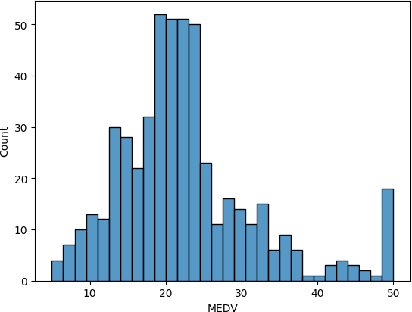

# Histogram for MEDV

sns.histplot(dataframe ['MEDV'], bins = 30) plt.show()

The MEDV appears to have a neary normal distribution without skew, which cen be processed

# Creating Histogram for each distribution of the varibales dataframe.hist(edgecolor = 'Red', figsize = (14, 12))

plt.show()

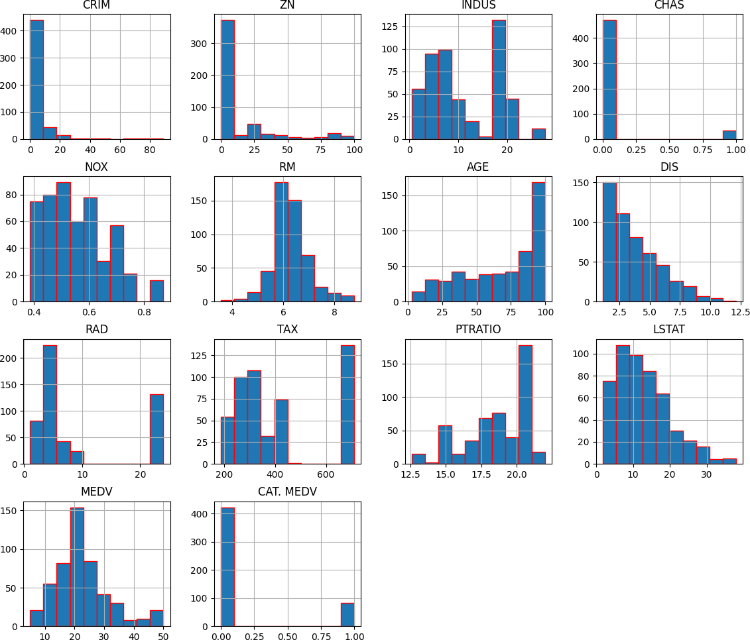

Obersations:

Histograms show the distribution of data points. CRIM, ZN, and LSTAT are skewed right, indicating a concentration of lower values with fewer high values. RM appears normally distributed, suggesting most homes have a moderate number of rooms. AGE and DIS indicate a range of old to new houses and varied proximity to employment centers. TAX and RAD show clusters, indicating common tax rates and highway access levels. CHAS, with most values at 0, suggests few properties are by the river. MEDV shows house value distribution, and CAT. MEDV suggests

most homes fall below a certain value threshold. These visualizations help in understanding the spread and concentration of data points across

the variables.

 Bivariate Analysis

# Correlation heatmap Useing plt.figure(figsize=(12, 10))

sns.heatmap(dataframe.corr(), annot =True, fmt = ".2f") plt.show()

# scatter plot to visulaize the relationship between RM Vs MEDV sns.scatterplot(data = dataframe, x = "RM", y = "MEDV")

plt.show()

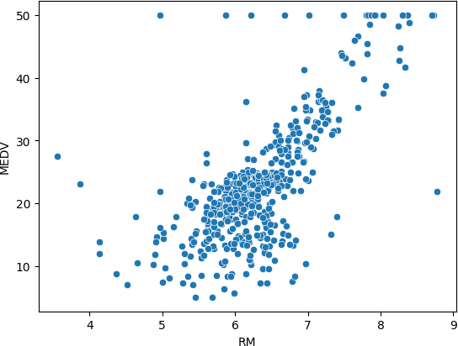

Observation:

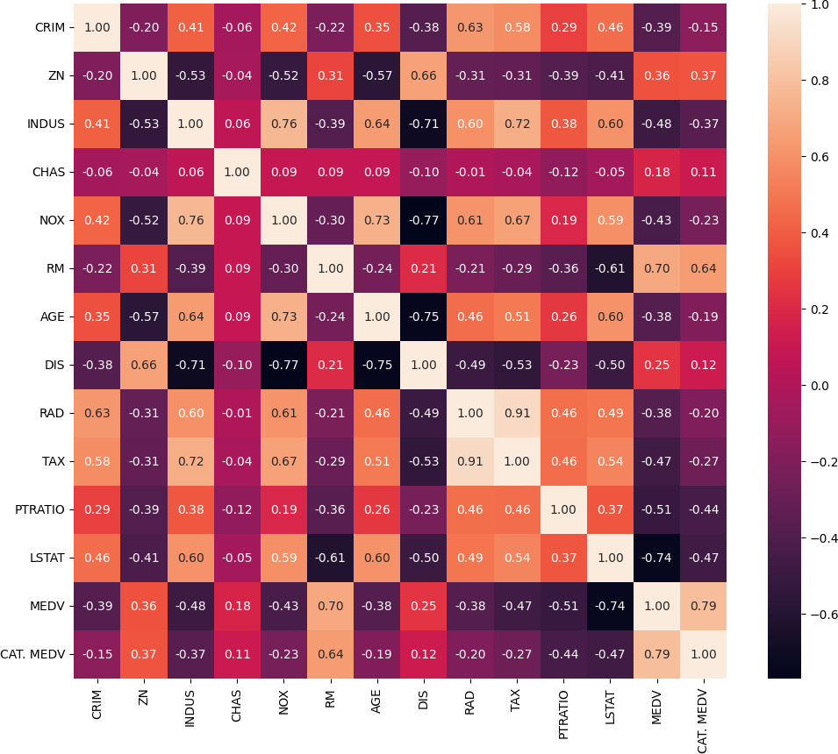

 Observations:

Values close to 1 or -1 indicate a strong positive or negative correlation, respectively, while values near 0 show little to no linear

relationship.

A high positive value between RAD and TAX suggests towns with more highways tend to have higher tax rates.

A high negative correlation between DIS and NOX implies that closer proximity to employment centers often coincides with lower air quality.

RM seems to have a higher positive correlation with MEDV and CAT. MEDV LSTAT seems highly negatively correlated with MEDV and CAT. MEDV

CRIM, AGE, and RAD are also positively correlated with MEDV and CAT.MEDV seems to have a higher positive correlation with those independent variables compared to MEDV.

CRIM seems to have a positive correlation with RAD and TAX

 Scatter plots

The price of the house seems to increase as the values of RM increases that's expected as the prices is generally higher for more rooms. There are a few outliers in a horizontal line as the MEDV values seems to be capped at 50

#  Creating Box Plots

dataframe.plot(kind="box", subplots=True, layout=(5,3), sharex=False, figsize=(20,18)) plt.show()

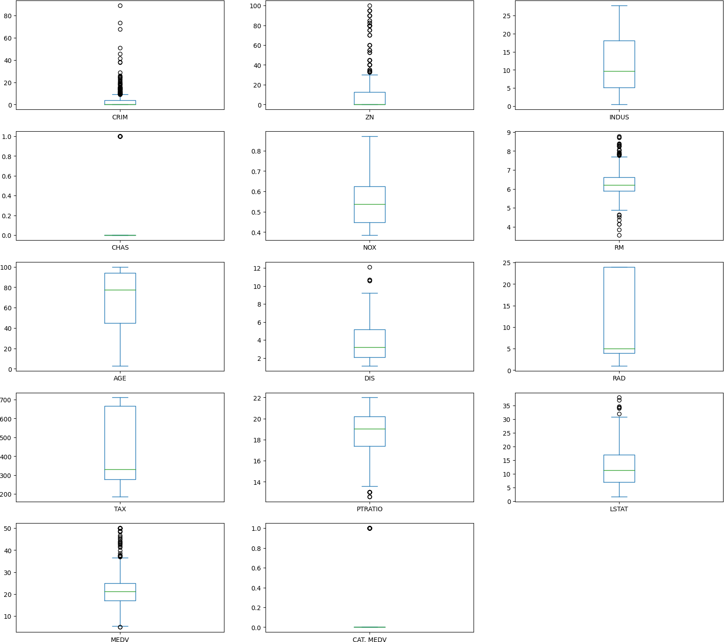

 Step 4 Separate the dataset into the input and output NumPy arrays

# Split the dataset into input and output arrays

X = dataframe.drop("MEDV", axis=1).values y = dataframe["MEDV"].values

# Display the shapes of the input and output arrays print("X shape:", X.shape)

print("y shape:", y.shape)

X shape: (506, 13)

y shape: (506,)

The dataset is divided into input and output NumPy arrays in the fourth stage. The target variable (MEDV) is the only variable present in the output array (y), whereas all other variables are present in the input array (X)

#  Step 5 Split the input/output arrays into the training/testing datasets

# Use a 70/30 split to divide the input/output arrays into the training and testing datasets. # Everywhere you need it, use a seed of 7.

from sklearn.model_selection import train_test_split # Set a seed for reproducibility

seed = 7

# Split the data into training and testing sets

X_train, X_test, y_train, y_test = train_test_split(X, y, test_size=0.3, random_state=seed)

# Display the shapes of the training and testing sets print("X_train shape:", X_train.shape)

print("X_test shape:", X_test.shape) print("y_train shape:", y_train.shape) print("y_test shape:", y_test.shape)

X_train shape: (354, 13)

X_test shape: (152, 13)

y_train shape: (354,)

y_test shape: (152,)

Use a 70/30 split to divide the input/output arrays into the training and testing datasets. Everywhere you need it, use a seed of 7.

The train_test_split() method from Scikit-Learn is used to divide the input/output arrays into training and testing sets in the fifth phase. The

model is trained using 70% of the data, and tested using 30%, according to the code's 70/30 split. To ensure that the results can be replicated, the random_state option is set to 7

#  Step 6 Build and Train the Model

# Create a linear regression model object lr_model = LinearRegression()

# Train the model on the training set lr_model.fit(X_train, y_train)

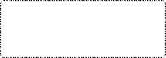

▾ LinearRegression

LinearRegression()

The LinearRegression() class from Scikit-Learn is used in the sixth step to create and train a linear regression model on the training data.

#  Step 7 Calculate the R2 Values

#from sklearn.metrics import r2_score

# Make predictions on the test set y_pred = lr_model.predict(X_test)

# Calculate the R2 score

r2 = r2_score(y_test, y_pred)

# Display the R2 score print("R2 score:", r2)

# Plot the actual vs predicted values plt.figure(figsize=(10, 6))

plt.scatter(y_test, y_pred, color='red', label='Predicted', alpha=0.5)

plt.plot([y.min(), y.max()], [y.min(), y.max()], 'k--', lw=4, label='Actual') plt.title(f'Actual vs Predicted Values (R2 score: {r2:.2f})')

plt.xlabel('Actual values')

plt.ylabel('Predicted values') plt.legend()

plt.show()

R2 score: 0.8235857791570557

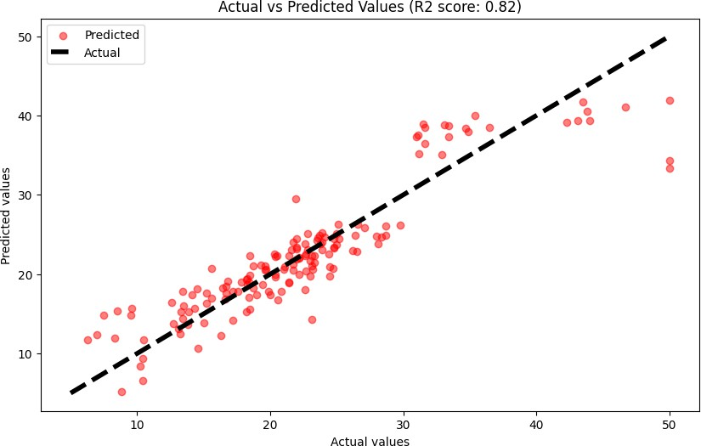

The value R-squared (R2) is a statistic that measures the portion of the outcome variation explained by the model's inputs. An R2 of 1 means perfect prediction, 0 means the model predicts no better than the average outcome, and a negative R2 indicates the model

performs worse than just using the average. It helps to assess the model's accuracy in predicting data.

The value R-squared (R2) score of 0.82, the model has a high level of predictive accuracy, it’s indicating less accuracy in the predictions for those values.

#  Step 8 Predict the "Median value of owner-occupied homes in 1000 dollars"

It is assumed that two new suburbs/towns/developments have been established in the Boston area. The agency has collected the housing data of these two new suburbs/towns/developments.

Makeup two housing records to be used as predictors (all 5 variables except MEDV). You can choose any numbers you like. Hint: Look at the mean of each variable and choose a number close to that and then possibly take a value within the min/max and see how this changes the outcome.

Use these two new records as the new data, feed them into the model to predict the median value of owner-occupied homes in 1000’s dollars.

For each predictor, the student should clearly present the value of each predictor.

# Make a prediction for a new data point

new_data = np.array([[0.1, 18, 2.5, 0.5, 6, 70, 3, 2.5, 10, 400, 20, 400, 10]])

prediction = lr_model.predict(new_data)

# Display the predicted value

print("Predicted value:", prediction[0]) # Plot the prediction as a red point

plt.scatter(new_data[:, 0], prediction, color='red', label='Prediction')

# Adding labels and legend plt.xlabel('Actual values')

plt.ylabel('Predicted values')

plt.title('Linear Regression Prediction') plt.legend()

# Show plot plt.show()

Predicted value: 36.52756556971715

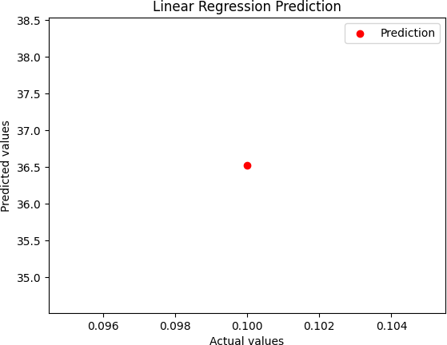

#  Step 9 Evaluate the model using the 10-fold cross-validation

from sklearn.model_selection import cross_val_score

# Calculate the cross-validation score

cv_score = cross_val_score(lr_model, X, y, cv=10)

# Display the cross-validation score

print("Cross-validation score:", cv_score.mean())

Cross-validation score: 0.5130037202325773

# Display the cross-validation score

print("Cross-validation scores:", cv_score)

print("Mean cross-validation score:", cv_score.mean())

# Plot the cross-validation scores plt.figure(figsize=(10, 6))

plt.plot(range(1, 11), cv_score, marker='o', linestyle='-', color='blue') plt.title('Cross-Validation Scores for Each Fold')

plt.xlabel('Fold Number') plt.ylabel('CV Score')

plt.grid(True)

plt.xticks(range(1, 11)) plt.show()

Cross-validation scores: [ 0.78728013 0.77163074 -0.04735138 0.78583874 0.71735972

0.55832355 0.46846597 -0.16638564 0.55947839]

Mean cross-validation score: 0.5130037202325773

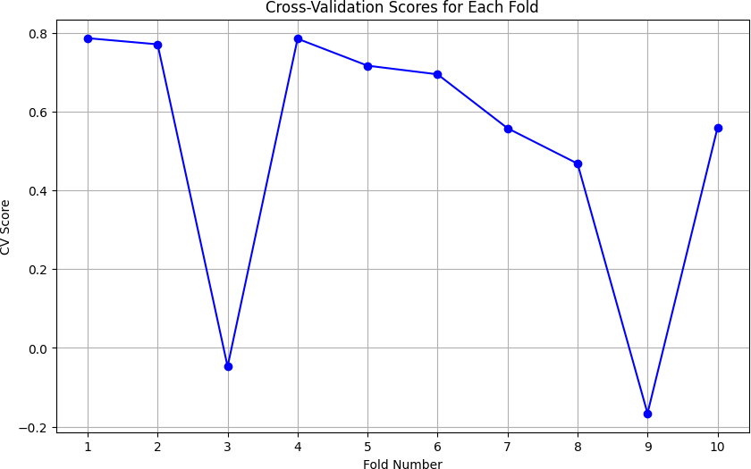

The model will be assessed using 10-fold cross-validation in the last stage. The code computes the cross-validation score, which is a gauge of how effectively the model generalises to new data, using the cross_val_score() function from Scikit-Learn. The user sees the overall cross-

validation score

#  Linear Regression Build and Train the Model:

Discussion of the ethical concerns Comparing with Random Forest Regressor, XGBoost Regressor, SVM Regressor

# # Load the dataset Overview

data = pd.read_csv ("BostonHousing.csv") # data.head(5)

# We can clean the dateset and missing values data.isnull().sum()

# Handle missing values if any dataframe.dropna(inplace=True)

# Split the dataset into input and output arrays

X = data.drop("MEDV", axis=1).values y = data["MEDV"].values

# Splitting to training and testing data

from sklearn.model_selection import train_test_split

X_train, X_test, y_train, y_test = train_test_split(X,y, test_size = 0.3, random_state = 4)

Training the Model

# Import library for Linear Regression

from sklearn.linear_model import LinearRegression # Create a Linear regressor

lm = LinearRegression()

# Train the model using the training sets lm.fit(X_train, y_train)

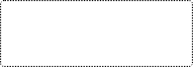

▾ LinearRegression

LinearRegression()

#  Model Evaluation

# Model prediction on train data y_pred = lm.predict(X_train)

# Model Evaluation

print('R^2:',metrics.r2_score(y_train, y_pred))

print('Adjusted R^2:',1 - (1-metrics.r2_score(y_train, y_pred))*(len(y_train)-1)/(len(y_train)-X_train.shape[1]-1)) print('MAE:',metrics.mean_absolute_error(y_train, y_pred))

print('MSE:',metrics.mean_squared_error(y_train, y_pred))

print('RMSE:',np.sqrt(metrics.mean_squared_error(y_train, y_pred)))

# Visualizing the differences between actual prices and predicted values plt.scatter(y_train, y_pred)

plt.xlabel("Prices")

plt.ylabel("Predicted prices")

plt.title("Prices vs Predicted prices") plt.show()

R^2: 0.8414010824968472

Adjusted R^2: 0.8353370062393737

MAE: 2.470761845814791

MSE: 11.937872104054614

RMSE: 3.455122588860577

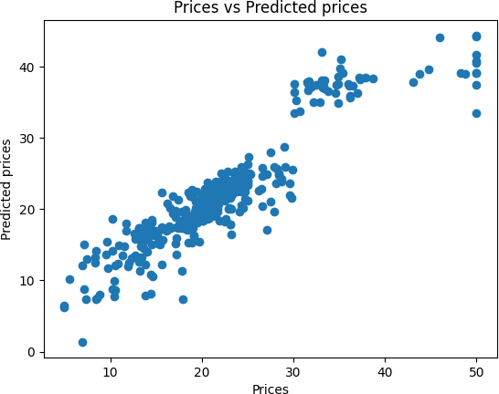

# Checking residuals

plt.scatter(y_pred,y_train-y_pred) plt.title("Predicted vs residuals") plt.xlabel("Predicted")

plt.ylabel("Residuals") plt.show()

R^2: 0.8282476420395907

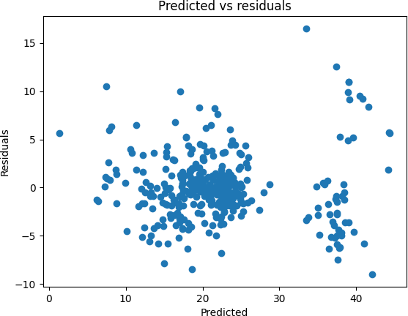

 For Test data

# Model Evaluation

acc_linreg = metrics.r2_score(y_test, y_test_pred) print('R^2:', acc_linreg)

print('Adjusted R^2:',1 - (1-metrics.r2_score(y_test, y_test_pred))*(len(y_test)-1)/(len(y_test)-X_test.shape[1]-1)) print('MAE:',metrics.mean_absolute_error(y_test, y_test_pred))

print('MSE:',metrics.mean_squared_error(y_test, y_test_pred))

print('RMSE:',np.sqrt(metrics.mean_squared_error(y_test, y_test_pred)))

# Predicting Test data with the model y_test_pred = lm.predict(X_test)

Adjusted R^2: 0.8120680720867985

MAE: 3.181336453546118

MSE: 17.93439363280514

RMSE: 4.2349018445301825

Here the model evaluations scores are almost matching with that of train data. So the model is not overfitting.

#  Random Forest Regressor

Train the model

# Import Random Forest Regressor

from sklearn.ensemble import RandomForestRegressor

# Create a Random Forest Regressor reg = RandomForestRegressor()

# Train the model using the training sets reg.fit(X_train, y_train)

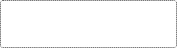

▾ RandomForestRegressor

RandomForestRegressor()

#  Model Evaluation

# Model prediction on train data y_pred = reg.predict(X_train)

# Model Evaluation

print('R^2:',metrics.r2_score(y_train, y_pred))

print('Adjusted R^2:',1 - (1-metrics.r2_score(y_train, y_pred))*(len(y_train)-1)/(len(y_train)-X_train.shape[1]-1)) print('MAE:',metrics.mean_absolute_error(y_train, y_pred))

print('MSE:',metrics.mean_squared_error(y_train, y_pred))

print('RMSE:',np.sqrt(metrics.mean_squared_error(y_train, y_pred)))

# Visualizing the differences between actual prices and predicted values plt.scatter(y_train, y_pred)

plt.xlabel("Prices")

plt.ylabel("Predicted prices")

plt.title("Prices vs Predicted prices") plt.show()

R^2: 0.9863523167944653

Adjusted R^2: 0.9858304936130773

MAE: 0.7494717514124284

MSE: 1.0272724378531066

RMSE: 1.013544492290845

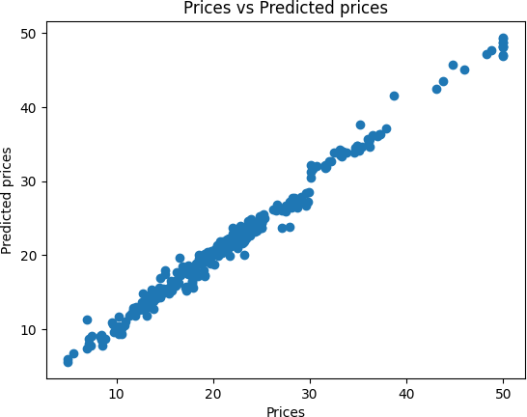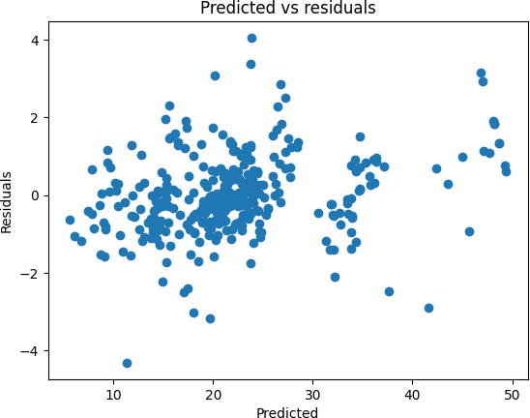

# Checking residuals

plt.scatter(y_pred,y_train-y_pred) plt.title("Predicted vs residuals") plt.xlabel("Predicted")

plt.ylabel("Residuals") plt.show()

#  For Test Data

# Predicting Test data with the model y_test_pred = reg.predict(X_test)

# Model Evaluation

acc_rf = metrics.r2_score(y_test, y_test_pred) print('R^2:', acc_rf)

print('Adjusted R^2:',1 - (1-metrics.r2_score(y_test, y_test_pred))*(len(y_test)-1)/(len(y_test)-X_test.shape[1]-1)) print('MAE:',metrics.mean_absolute_error(y_test, y_test_pred))

print('MSE:',metrics.mean_squared_error(y_test, y_test_pred))

print('RMSE:',np.sqrt(metrics.mean_squared_error(y_test, y_test_pred)))

R^2: 0.9171679831741177

Adjusted R^2: 0.9093649670963172

MAE: 2.1351842105263152

MSE: 8.649325184210529

RMSE: 2.9409735096070704

#  XGBoost Regressor

Training the model



▾

XGBRegressor

XGBRegressor(base_score=None, booster=None, callbacks=None,

colsample_bylevel=None, colsample_bynode=None,

colsample_bytree=None, device=None, early_stopping_rounds=None, enable_categorical=False, eval_metric=None, feature_types=None, gamma=None, grow_policy=None, importance_type=None,

interaction_constraints=None, learning_rate=None, max_bin=None, max_cat_threshold=None, max_cat_to_onehot=None,

max_delta_step=None, max_depth=None, max_leaves=None,

min_child_weight=None, missing=nan, monotone_constraints=None, multi_strategy=None, n_estimators=None, n_jobs=None,

num_parallel_tree=None, random_state=None, ...)

max_depth (int) – Maximum tree depth for base learners. learning_rate (float) – Boosting learning rate (xgb’s “eta”) n_estimators (int) – Number of boosted trees to fit.

# Import XGBoost Regressor

from xgboost import XGBRegressor

#Create a XGBoost Regressor reg = XGBRegressor()

# Train the model using the training sets reg.fit(X_train, y_train)

gamma (float) – Minimum loss reduction required to make a further partition on a leaf node of the tree. min_child_weight (int) – Minimum sum of instance weight(hessian) needed in a child.

subsample (float) – Subsample ratio of the training instance.

colsample_bytree (float) – Subsample ratio of columns when constructing each tree.

objective (string or callable) – Specify the learning task and the corresponding learning objective or a custom objective function to be used (see note below).

nthread (int) – Number of parallel threads used to run xgboost. (Deprecated, please use n_jobs) scale_pos_weight (float) – Balancing of positive and negative weights.

#  Model Evaluation

# Model prediction on train data y_pred = reg.predict(X_train)

# Model Evaluation

print('R^2:',metrics.r2_score(y_train, y_pred))

print('Adjusted R^2:',1 - (1-metrics.r2_score(y_train, y_pred))*(len(y_train)-1)/(len(y_train)-X_train.shape[1]-1)) print('MAE:',metrics.mean_absolute_error(y_train, y_pred))

print('MSE:',metrics.mean_squared_error(y_train, y_pred))

print('RMSE:',np.sqrt(metrics.mean_squared_error(y_train, y_pred)))

# Visualizing the differences between actual prices and predicted values plt.scatter(y_train, y_pred)

plt.xlabel("Prices")

plt.ylabel("Predicted prices")

plt.title("Prices vs Predicted prices") plt.show()

R^2: 0.9999971337737482

Adjusted R^2: 0.9999970241827445

MAE: 0.010238739056775834

MSE: 0.0002157432279690282

RMSE: 0.014688200297144242

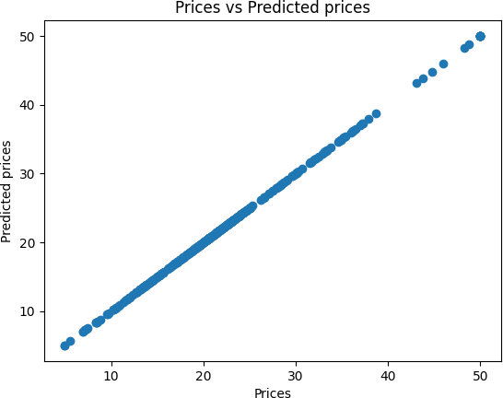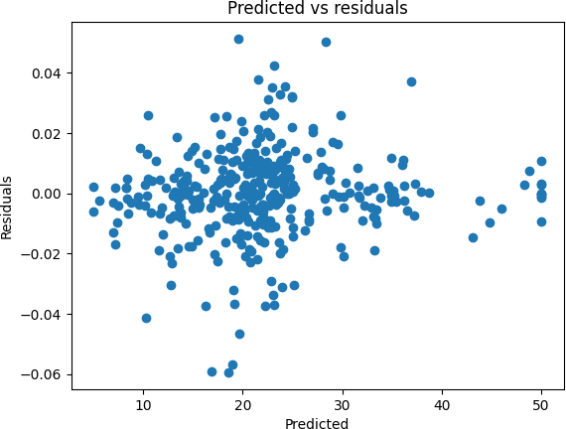

# Checking residuals

plt.scatter(y_pred,y_train-y_pred) plt.title("Predicted vs residuals") plt.xlabel("Predicted")

plt.ylabel("Residuals") plt.show()

#  For test data

#Predicting Test data with the model y_test_pred = reg.predict(X_test)

# Model Evaluation

acc_xgb = metrics.r2_score(y_test, y_test_pred) print('R^2:', acc_xgb)

print('Adjusted R^2:',1 - (1-metrics.r2_score(y_test, y_test_pred))*(len(y_test)-1)/(len(y_test)-X_test.shape[1]-1)) print('MAE:',metrics.mean_absolute_error(y_test, y_test_pred))

print('MSE:',metrics.mean_squared_error(y_test, y_test_pred))

print('RMSE:',np.sqrt(metrics.mean_squared_error(y_test, y_test_pred)))

R^2: 0.8974572137913375

Adjusted R^2: 0.8877973861050141

MAE: 2.2988646846068534

MSE: 10.707525147891445

RMSE: 3.272235497009872

 SVM Regressor

# Creating scaled set to be used in model to improve our results from sklearn.preprocessing import StandardScaler

sc = StandardScaler()

X_train = sc.fit_transform(X_train) X_test = sc.transform(X_test)

 Train the model

# Import SVM Regressor from sklearn import svm

# Create a SVM Regressor reg = svm.SVR()

# Train the model using the training sets reg.fit(X_train, y_train)



▾ SVR

SVR()

 Model Evaluation

# Model prediction on train data y_pred = reg.predict(X_train)

# Model Evaluation

print('R^2:',metrics.r2_score(y_train, y_pred))

print('Adjusted R^2:',1 - (1-metrics.r2_score(y_train, y_pred))*(len(y_train)-1)/(len(y_train)-X_train.shape[1]-1)) print('MAE:',metrics.mean_absolute_error(y_train, y_pred))

print('MSE:',metrics.mean_squared_error(y_train, y_pred))

print('RMSE:',np.sqrt(metrics.mean_squared_error(y_train, y_pred)))

# Visualizing the differences between actual prices and predicted values plt.scatter(y_train, y_pred)

plt.xlabel("Prices")

plt.ylabel("Predicted prices")

plt.title("Prices vs Predicted prices") plt.show()

R^2: 0.701944593484767

Adjusted R^2: 0.6905483573533022

MAE: 2.656200288570808

MSE: 22.43487773382895

RMSE: 4.736547026455976

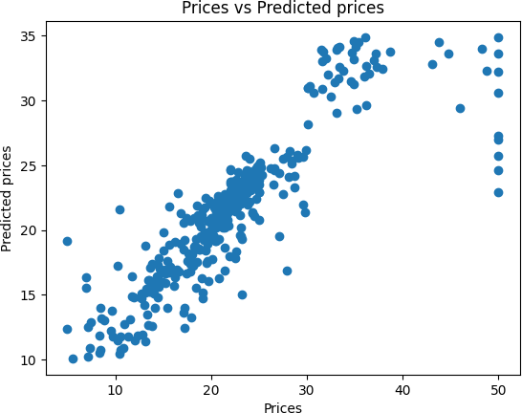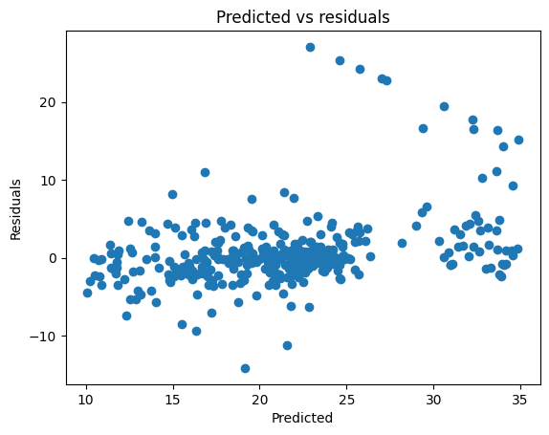

# Checking residuals

plt.scatter(y_pred,y_train-y_pred) plt.title("Predicted vs residuals") plt.xlabel("Predicted")

plt.ylabel("Residuals") plt.show()

#  For test data

# Predicting Test data with the model y_test_pred = reg.predict(X_test)

# Model Evaluation

acc_svm = metrics.r2_score(y_test, y_test_pred) print('R^2:', acc_svm)

print('Adjusted R^2:',1 - (1-metrics.r2_score(y_test, y_test_pred))*(len(y_test)-1)/(len(y_test)-X_test.shape[1]-1)) print('MAE:',metrics.mean_absolute_error(y_test, y_test_pred))

print('MSE:',metrics.mean_squared_error(y_test, y_test_pred))

print('RMSE:',np.sqrt(metrics.mean_squared_error(y_test, y_test_pred)))

R^2: 0.6549051060963801

Adjusted R^2: 0.6223961668156043

MAE: 3.5374033490571284

MSE: 36.0348337655154

RMSE: 6.002902111938475

#  Evaluation and comparision of all the models

models = pd.DataFrame({

'Model': ['Linear Regression', 'Random Forest', 'XGBoost', 'Support Vector Machines'], 'R-squared Score': [acc_linreg*100, acc_rf*100, acc_xgb*100, acc_svm*100]})

models.sort_values(by='R-squared Score', ascending=False)

|  |  |  |
| --- | --- | --- |
|  | **Model** | **R-squared Score** |
| **1** | Random Forest | 91.716798 |
| **2** | XGBoost | 89.745721 |
| **0** | Linear Regression | 82.824764 |
| **3** | Support Vector Machines | 65.490511 |

[https://www.kaggle.com/code/shreayan98c/boston-house-price-prediction](https://colab.research.google.com/corgiredirector?site=https%3A%2F%2Fwww.kaggle.com%2Fcode%2Fshreayan98c%2Fboston-house-price-prediction)

# Final Part 1